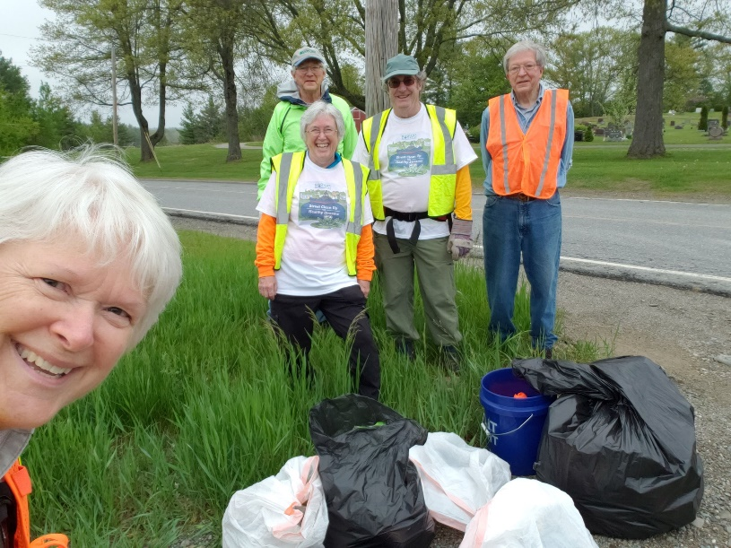No Trash in the River!

The Lower East Fork White River watershed coordinator, Julie Loehr, would like to invite you to join the “No Trash in the River” movement - an anti-littering campaign in Daviess, Dubois, Martin and Pike Counties. You don’t have to live in the watershed to participate, but you do have to be concerned about trash along our roads and in natural areas!

There are two ways you can help:

1) Join the “No Trash in the River” challenge by gathering friends / family and heading out to your favorite outdoor area to pick up litter and help restore the natural area to health. Whether a roadside, a local park, or your subdivision, picking up litter keeps it from our creeks and streams. When you’re done, take a picture (like the one shown here) showcasing the bags of trash or items collected as well as the volunteers that helped. Then send the picture to watershed coordinator Julie Loehr in a text at 812-779-7924 or via email to [Julia.loehr@in.nacdnet.net](mailto:Julia.loehr@in.nacdnet.net). Your group’s picture will be entered into the “No Trash in the River” contest. One winner will be chosen from each county by December 31, 2024 and that group will then be invited to the local Soil and Water Conservation District’s annual meeting to receive their award, recognition and thanks.

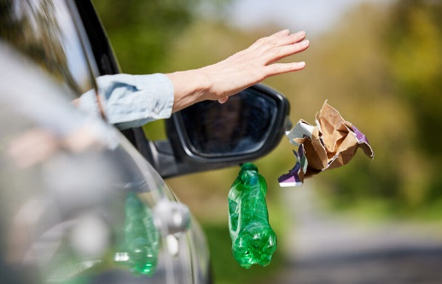2) If you can’t physically get outside to collect trash, please talk to your neighbors, friends, co-workers and family about not throwing trash out the car window. Remind them that eventually they will have to stop at a gas station to fill up and can dispose of all trash then. You can also personally pledge to not throw any trash out of your car window or let any passenger do so.

Together we can clean up our neighborhoods and help ensure “No Trash in the River”.